DIAGNOSTIC TOOLKITS
IDB Guide to Support Road Safety Projects

Hilda María Gómez V.
Consultant – Inter-American Development Bank

- Introduction

Although diagnostic experiments in the field of road safety have been carried out in some countries of Latin America and the Caribbean (LAC), such as those included in the “World Report on Prevention of Road Traffic Injuries” (World Health Organization, 2004), “Health in the Americas” (Pan-American Health Organization, 2007) and “Road Safety in the Region of Latin America and the Caribbean. Current Situation and Challenges” (United Nations Economic Commission for Latin America and the Caribbean, 2005), they are generally reports containing general data which, although they provide an overview of the situation in the region, do not permit identification of specific problems which provide the basis for finding solutions for each country.

Reports such as those produced by the Argentine Institute of Road Safety and Education offer a more specific view of certain aspects, such as road safety education or the institutionalization of road safety, while the Inter-American Development Bank (IDB) has led in-depth analysis initiatives in some countries, such as Colombia, whose conclusions appear in the report “Road Safety in Colombia” (IDB, 2007).

However, in the search for solutions to road safety problems in LAC, what is needed is an in-depth diagnostic of the situation of the countries and some conclusions about strategic aspects of road safety in the region. The IDB, aware of the importance of a good diagnostic of road safety management as part of a hired consulting service to develop an IDB action strategy in the field of road safety, included a diagnostic of road safety in borrowing countries as the first stage of the consulting service. Thus, in November 2008, the diagnostic got under way in 26 countries, with a view to obtaining the conclusions on which the IDB Action Plan and the Guide to Support Road Safety Projects will be based.

- THE IMPORTANCE OF THE DIAGNOSTIC

The World Health Organization recommends focusing on the diagnostic in the conclusions of the “World Report on Prevention of Road Traffic Injuries. Elements for Decision-Making”:

“Assess the problem, policies and institutional settings relating to road traffic injury and the capacity for road traffic injury prevention in each country”.

To carry out an appropriate diagnostic in the region, the following aspects must be covered:

- In relation to the user factor, the aspects which must be assessed include procedures for obtaining driving licences, medical examinations to determine driver aptitude, road safety education and training, and awareness-raising campaigns.

- In relation to infrastructure, it is important not to overlook any road safety criteria which may have been included in the planning, design, construction and operation phases, either through management of accident concentration sections or road safety audits, for example. The urban environment must be given special priority in this aspect of the diagnostic, due to the high accident rates recorded.

- In relation to the vehicle, it is necessary to know the characteristics of the fleet, as well as its age and its road safety equipment. School transport and, in general, passenger and goods transport (especially dangerous goods) require a specific assessment, due to the serious consequences of an accident involving vehicles carrying goods or large numbers of people.

- In relation to the legal-legislative framework, all the laws and regulations affecting the abovementioned factors must be assessed, with special attention being paid to enforcement mechanisms, given that a comprehensive legal framework does not guarantee good results if there are no such mechanisms to ensure compliance with the laws.

- THE INTER-AMERICAN DEVELOPMENT BANK’S ROAD SAFETY DIAGNOSTIC.

  - The Inter-American Development Bank’s road safety strategy.

The Spanish Road Association (Asociación Española de la Carretera) has been engaged under contract by the IDB to carry out a consulting project which is due to finish in October 2009, its main purpose being to develop an action strategy for the IDB in the field of road safety, which includes drawing up an Action Plan and a developing a tool (IDB Guide to Support Road Safety Projects) to propose road safety actions in the projects in which the IDB participates, with a view to it being used by borrowing countries and the Bank’s professionals. The project also includes six pilot assessment and support for the Regional Road Safety Committee (Comité Regional de Seguridad Vial).

The first stage of this project consists in preparing a diagnostic of road safety in LAC. This in-depth analysis adds significant value to diagnostics carried out in the region to date, and will be accompanied by a similar strategy to the one used by the Pan-American Health Organization, in the search for coordination and complementarity among road safety institutions in LAC.

  - Aims of the diagnostic.

The aim of the LAC road safety diagnostic included in the abovementioned consulting project is to produce a knowledge base regarding the current situation of all the factors involved in road safety in LAC countries. This information will be used during the course of this consulting project and in other projects of interest, as well as for the purpose of categorizing countries in terms of road safety, making comparisons between LAC countries and with countries in other parts of the world, and compiling successful national or regional experiences which could be of use in other contexts.

More specifically, both the diagnostic conclusions and the in-depth analysis of initiatives carried out by other institutions in the region will provide the basis for the IDB’s Road Safety Action Plan, and will also be used as reference information when preparing the IDB Guide to Support Road Safety Projects.

  - Diagnostic phases.

The following diagnostic stages have been defined:

- Stage 1: Compiling information and successful experiences.

The following information fields are being covered in the 26 LAC countries in which the IDB operates, from the integral perspective that should be the basis of road safety management and, therefore, of the diagnostic:

  - Accident rate data:
    - Evolution of the number of accidents with victims, fatalities and injured persons in traffic accidents in recent years, differentiating between urban and interurban environments.
    - Accident causes.
    - Procedures and effectiveness of accident victim health care systems.

  - In relation to road safety policy:
    - Road safety institutions in the region.
    - Road safety funding.
    - Existence of road safety plans or strategies.

  - Aspects relating to infrastructure:
    - Length of the road network.
    - Network characterization by road type.
    - Procedures for detecting and dealing with accident concentration sections.
    - Actions for improving road safety in construction work.
    - Road safety criteria in road projects, including implementation of road safety audits.

  - In relation to users:
    - Characteristics of the process of obtaining a driving licence.
    - Road safety education programmes in schools.
    - Medical examinations for drivers.
    - Retraining courses for offending drivers.
    - Awareness-raising campaigns.

  - In relation to vehicles:
    - Vehicle fleet by type.
    - Age of vehicle fleet.
    - Motor vehicle inspection processes.
    - Control procedures for public transport and goods vehicles.

  - In relation to the legal, legislative and enforcement framework:
    - Road safety laws and design regulations.
    - Traffic laws, especially as regards speed limits, blood alcohol level, driving and resting times, and specific legislation on school transport and dangerous goods.
    - Existence of a single driver register.
    - Accident data collection system.
    - Accident reconstruction process.
    - Law enforcement results, including reference to controls and penalties.
    - Existence of compulsory motor vehicle insurance and degree of fulfilment.

This phase also includes compiling successful experiences in countries or regions, which could serve as references for their implementation in other countries, in all safety-related fields.

- Stage 2: Analysing the information and establishing country categories.

The information gathered during the first phase is analysed and the country categories are defined according to various criteria, so that the most appropriate one can be chosen for its consideration in the subsequent phases of the project.

The procedure designed for country categorization consists in analysing the strengths and weaknesses of each country by applying a Categorization Matrix. The assessment on which the categorization matrix is based must be dynamic, i.e. it must be reviewed every so often in order to adjust the categorization to the actual situation at any given time.

According to the score obtained in the Categorization Matrix, the analysed country is classified, in this first diagnostic, in one of these three categories:

  - Country with structural road safety problems.
  - Country with unstructured road safety actions.
  - Country with stable road safety structure.

- Stage 3: Comparative analysis between LAC countries and other countries in the world.

Once the Categorization Matrices for the analysed countries have been completed, the results are ordered, according to the rating obtained, in a comparative table which will be used to create a Positioning Map.
The Positioning Map puts each country in a certain position according to the ratings obtained for each aspect analysed (human factor, vehicle factor, infrastructure factor and institutions-legislation).
This will make it easy to rapidly verify:

- The situation of the countries in relation to an optimum reference.
- The countries which are in a similar situation to the country analysed.
- The weakest factors of the country analysed.
- The distance between some countries and others, both in each one of the factors and in general terms.

Graph 1 shows an example of the Positioning Map applied to two hypothetical countries:
Graph 1: Example of positioning map.
Strengths COUNTRIES WITH STABLE RS STRUCTURE
COUNTRIES WITH UNSTRUCTURED RS ACTIONS
COUNTRIES WITH STRUCTURAL RS PROBLEMS
Country 1 Country 2
Weaknesses
Human Factor Vehicle Factor Infrastructure Factor Institutions, laws and legislation
Overall Position
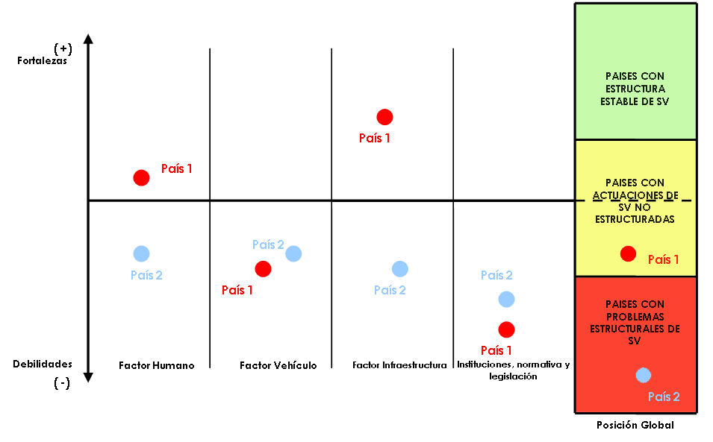(Source: independently produced)
As a follow-up to the diagnostic phase, the LAC countries are compared with each other and also with other countries (United States, Spain and other European countries such as Sweden, United Kingdom, Holland, among others), so that the LAC situation can be positioned in relation to these other countries.

- PROJECT GUIDE

The aim of this guide is to offer LAC agencies in charge of infrastructure and road safety a practical tool for identifying recommended measures to mitigate specific risk factors at a general level, or for specific projects, in accordance with the previous experiences of LAC countries

This IDB Guide should serve as a reference document for the governments of borrowing countries and for IDB officials, thus enabling them to plan road safety projects or projects with significant implications for road safety. One of the main characteristics of the Guide is its simplicity, whereby it can be used and fully exploited not only by road safety experts, but also professionals in other fields.

The secondary aims of the Guide are to:

- Facilitate identification of road safety programmes and projects.
- Raise awareness of the magnitude of the accident rate in a country or region by providing guidelines for updating the road safety diagnostic of the country or region in question.
- Alert the agents involved in the road transport system to the possibility of preventing the problem of road accidents by describing road safety improvement measures.
- Urge implementation of a coordinated approach among the various sectors in order to improve the situation.
- Make useful recommendations for local and national action thanks to the catalogue of problems and solution proposals and the criteria for identifying optimal measures and solutions.
- Promote the transfer of road safety know-how.

- PRINCIPLES OF THE idb guide

The Guide is being developed in accordance with the following principles, in order to make sure its full potential can be exploited by users:

- Describing simply and clearly the types of activities and type of analysis to be carried out from the road safety point view, for each type of intervention (construction of new roads, improvement of existing roads, maintenance).
- Indicating, for each type of intervention, the most suitable types of action to be carried out, according to the specific situation of each country.
- Specifying the types of action recommended for each project execution stage (planning, design, construction, operation).
- Allowing it to be used in the analysis of interurban transport programmes or projects, urban highway administration and public passenger transport systems.
- Containing institutional, management, legislative, education and road design and construction aspects.
- Based on successful experiences and cases in the region, in order to recommend them, on the basis of their results, as solutions to problems.
- In order to ensure proper use, the Guide will be adapted to the previously identified potential users.

- NEED FOR THE idb GUIDE

Very often, the types of actions included in road safety projects basically relate to adequate signage on the roads in question, due in many cases to the lack of guidance as to the types of analyses that should be carried out to reduce the accident rate. The IDB Guide for road safety projects will give decision-makers a multidisciplinary tool to help tackle existing road safety problems by using efficient methods and measures.

- potenTIal USERS

The Guide aims to be a reference document for IDB officials and for the governments of borrowing countries, thus enabling them to plan road safety projects or projects with significant implications for road safety.

Likewise, the Guide is also useful for engineers, planners and other professionals responsible for the road network for the purpose of improving the road safety of existing and future infrastructures. It will also help all the other agents involved in road safety to work on the different aspects in such a way as to promote road safety and ensure safer roads, drivers, pedestrians and vehicles.

- structurE AND contenTs

The Guide is divided into nine main sections and various appendices. The main sections are:

- INTRODUCTION. This first section contains the background, the purpose and aims of the Guide, the sources of additional documentation and the document’s limitations.

- HOW TO USE THE GUIDE. This section offers users the necessary guidelines on how to make the most of the IDB Guide. The entire process is clearly described, from the decision to undertake actions aimed at improving road safety to the execution of the project and the final assessment.

- GUIDELINES FOR THE DIAGNOSTIC OF A COUNTRY OR REGION. This section provides a detailed description of the strategy for updating and identifying the category of a country or region in relation to road safety.

- PRIORITY ROAD SAFETY IMPROVEMENT AREAS. This section characterizes the priority road safety improvement areas on the basis of the previously established country categories.

- CATALOGUE OF ROAD SAFETY IMPROVEMENT MEASURES. The main body of the Guide is the section on road safety improvement measures, structured according to the factors involved in road safety: institutional setting, human factor, vehicles and infrastructure. All the infrastructure life stages will be covered: planning, design and management, as well as mass transit projects. Therefore, the measures will be structured according to the type of intervention to be carried out.

- CATALOGUE OF PROBLEMS AND SOLUTION PROPOSALS. This section describes possible solutions to the most common road safety problems, aimed at the agent involved in each case, dealing with the institutional determining factors, the problems facing users, the shortcomings of vehicles and the deficiencies of infrastructures. Like the catalogue of measures, the catalogue of problems and their solutions will also be structured according to the type of intervention in question.

- CRITERIA FOR IDENTIFYING OPTIMAL MEASURES AND SOLUTIONS. This section provides criteria on the costs associated with the accident rate and on cost-benefit analysis, and describes an assessment system based on multiple criteria which will allow Guide users to identify the most suitable measures and solutions for each case, i.e. according to the action to be carried out. The Guide will consider successful experiences in the region and recommend their implementation in accordance with the problem in question.

- REPRESENTATIVE CASE STUDIES. This section includes case studies which serve as an example of how to use this tool, such as construction of a town by-pass, construction of a new route, widening of a roadbed or introduction of a new public transport line in an urban/rural environment.

- CONCLUSIONS. This final section contains the most important conclusions regarding the development and contents of the Guide.

- EFFECTIVE USE OF THE IDB GUIDE

In order to make sure users exploit the full potential of the Guide, the second section of the Guide provides clear and direct instructions on how to use it.

Four main stages will be identified: identification of the problem; diagnostic and priorities; analysis and proposals; and the final stage of assessment and verification. In each phase, the actions to be carried out and necessary tools for this purpose are indicated.

In the first phase, it is advisable to carry out an up-to-date Road Safety diagnostic, in order to identify the priority areas and spheres of activity for the country in question. In any case, the decision to carry out the diagnostic will depend on the scope of the intended project and on whether the diagnostic conclusions are necessary for the project’s execution.

The priority areas and spheres of activity are the source of information for the analysis and proposals phase, where, in parallel, the catalogue of measures and the catalogue of problems and solution proposals will serve to identify the optimal measures and solutions, respectively, all in accordance with the scope of the intended intervention. In addition to the optimal measures and solutions, the country must select the implementation and monitoring mechanisms, and thereby the country makes its proposal.

The final phase corresponds to implementation and subsequent assessment and verification. The country will execute the proposal and, upon completion, subject it to self-assessment, so that it can serve as a benchmark for improving future actions.

- iMPLEMENTATION OF THE IDB GUIDE.

The first version of the Guide should be available in May 2009. Over the following months, it will be necessary to test the tool in order to guarantee its effectiveness according to the purposes for which it has been designed. Thus, it is estimated that by the end of 2009 the Guide will be available on-line both for Inter-American Bank personnel and for the governments of borrowing countries.

In parallel, the Guide will be used in the pilot assessments envisaged in the context of the road safety consulting project, which will give rise to some conclusions regarding its effectiveness.

The Guide is a dynamic rather than static tool which should be updated on an annual basis in accordance with user recommendations and the results of new experiences in the region or in other countries.

- CONCLUSIONS.

Thanks to this up-to-date diagnostic of the institutional, financial, legal and technical situation of road safety in LAC, together with a practical tool in the form of the forthcoming IDB Guide to Support Road Safety Projects, as well as all the other aspects included in the Action Plan, the Bank will be given an important contribution toward improving road safety in the region.

